International Association of Plumbing and Mechanical Officials – India

Evaluation of Point of Use Drinking Water Purification systems – Specification IAPMO- I WPS-01:2019
Developed by
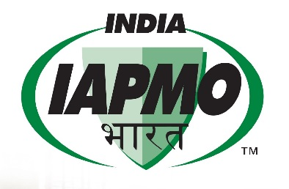
IAPMO Plumbing Codes and Standards India Private Limited (IAPMO India)
Published by
IAPMO-I
#43,4th Floor, PMR Tower, Above SBI, Beratena Agrahara, Hosur Main Road, Bangalore – 560 100
First Edition: 22nd April 2019

Copyright by
IAPMO Plumbing Codes and Standards India Private Limited ( IAPMO India)
All rights reserved
Without limiting the rights under Copyright reserved above, no part of this publication may be used, reproduced, translated or recorded in any form or by any means, except as may be expressly permitted in writing by the copyright owner.
Printed by ---------------------------------------
At ---------------- Printing press,--------------------------
This publication is sold, subject to the condition that it shall not by way of trade or otherwise, be lent, resold, hired out, or otherwise circulated without the copyright owner’s prior written consent in any form of binding or cover, other than that in which it is published and without a similar condition, including the condition being imposed on the subsequent purchase and without limiting the rights under copyright reserved above. No part of this publication may be reproduced, stored in or introduced into a retrieval system, or transmitted in any form or by any means (electronic, mechanical, photocopying, recording or otherwise), without the prior written permission of the copyright owner of this publication. Disputes, if any, will be subject to Bengaluru jurisdiction.
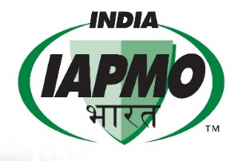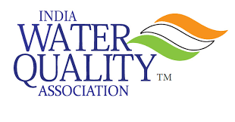

APPLICATION FORMAT FOR VOLUNTARY PARTICIPATION UNDER STANDARDS DEVELOPMENT WORKING GROUP MEMBERSHIP
Please fill all the boxes. Where not relevant please write as Not Applicable. Do not leave un filled.
S.No | Item Description | Response
1 | Category | Individual/ NGO/Manufacturer/ University/ Professor/ Engineer / Trader / Association representative/Others
 |  | Please specify if others is applicable
2 | Name & address with contact details.  Email id and Mobile number
3 | Are you a member ## of WQIA ( Water Quality Association) | Yes No
4 | Have you been a member of standards development committee in any of the organization. | Yes No  If yes, please describe briefly.
5. | Can you please describe briefly what is the benefit you are expecting by becoming a member of above mentioned working group.
6 | Educational Qualification, Industry, manufacturing, Technical experience etc. | Attach your resume also.
## All participants are recommended to become member of WQIA.

DECLARATION:

I ------------------------------------------------ as an individual / representative of M/s ------------------------ agree that I am voluntarily participating as a member of the working group and contribute to the standard development fully independently without any conflict of interest with my profession and this standard which is under development. I will contribute to share my feedback genuinely without undergoing any undue pressure from any individual or organization.
Also I am willing to attend meetings either by on-line or physically (though physical meeting is not mandatory) at my own interest and expenses. I also promise that I am available for telephonic discussion or email communication, if needed, even in the late hours (before 9.0 PM on a specified day). Also I fully abide by the ethical practice of not utilizing the testing procedures, content of this standard before it is published either for personal use or for my organization.
I obtained permission from my organization officially to participate in the above working group.
I also promise that during discussions in the meeting(s) I do not use any such vocabulary or reveal any information which is unethical, affecting anybody’s feelings and sentiments in the group.

All the above information provided by me, as above, is true to best of my knowledge.

Place Name:
Date: Title:
Signature:

